HOW TO SIGN UP TO BE A VOLUNTEER

- Go to the www.firstinpires.com website and login. This is the same website where you signed a consent and release form for your child.
- Go to your dashboard
- Select Volunteer Registration
- Select Event Volunteering
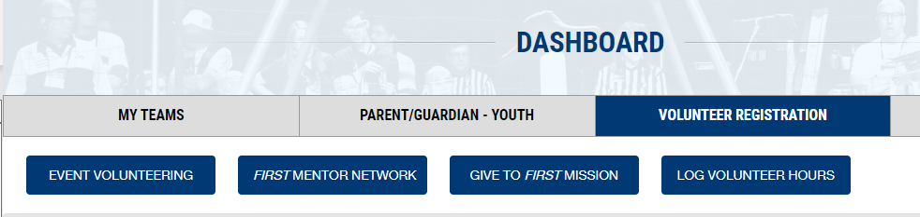

- Search for FIRST LEGO League Challenge in Oviedo, FL named the Jackson Heights Jamboree
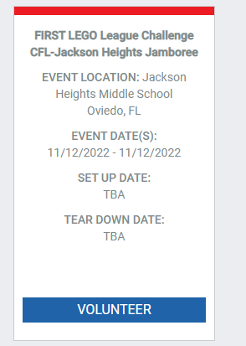
- You should see this

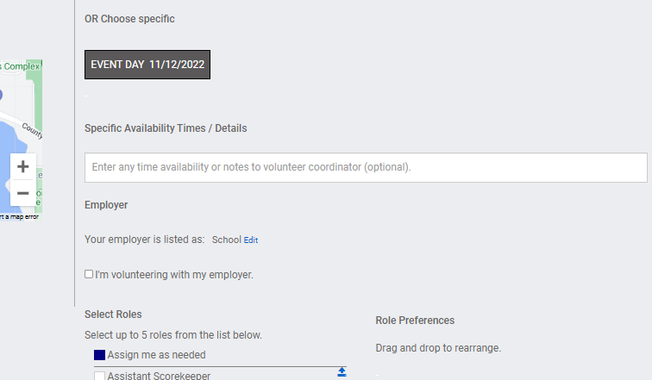
- Select volunteer
- Select “Event date”
- Please choose “Assign me as needed”
- Then click next

- Add our teams to this list : team # 920 and 10240 and any other team you may be affiliated with. 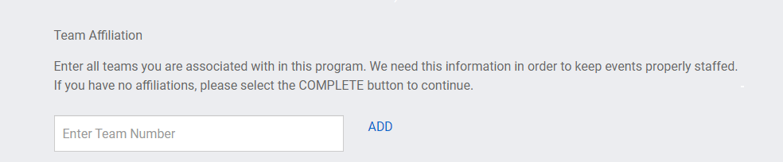

AT SOME POINT YOU WILL HAVE TO COMPLETE A BACKGROUND CHECK AND COMPLETE THE YOUTH PROTECTION SCREENING. More infomation to come on that.

